Libya

## Respect for rule of law (ROL) data

The data set shows the data on the respect of the rule of law for the country.

## # A tibble: 19 x 5  
## country iso3c date ruleOfLaw ruleOfLawCategory4   
## <chr> <chr> <dbl> <dbl> <chr>   
## 1 Libya LBY 1996 -1.18 ROL highly disrespected   
## 2 Libya LBY 1998 -1.11 ROL highly disrespected   
## 3 Libya LBY 2000 -0.990 ROL moderately disrespected  
## 4 Libya LBY 2002 -1.14 ROL highly disrespected   
## 5 Libya LBY 2003 -0.896 ROL moderately disrespected  
## 6 Libya LBY 2004 -0.909 ROL moderately disrespected  
## 7 Libya LBY 2005 -0.975 ROL moderately disrespected  
## 8 Libya LBY 2006 -1.08 ROL highly disrespected   
## 9 Libya LBY 2007 -0.951 ROL moderately disrespected  
## 10 Libya LBY 2008 -0.824 ROL moderately disrespected  
## 11 Libya LBY 2009 -0.934 ROL moderately disrespected  
## 12 Libya LBY 2010 -0.993 ROL moderately disrespected  
## 13 Libya LBY 2011 -1.20 ROL highly disrespected   
## 14 Libya LBY 2012 -1.14 ROL highly disrespected   
## 15 Libya LBY 2013 -1.34 ROL highly disrespected   
## 16 Libya LBY 2014 -1.51 ROL highly disrespected   
## 17 Libya LBY 2015 -1.63 ROL highly disrespected   
## 18 Libya LBY 2016 -1.82 ROL highly disrespected   
## 19 Libya LBY 2017 -1.78 ROL highly disrespected

## Respect for rule of law (ROL) trend

The plot shows the trend of the respect for the rule of law for the country.

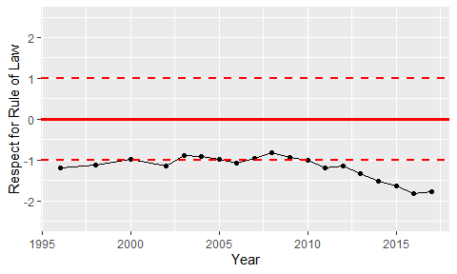

Trend of the Respect for the Rule of Law